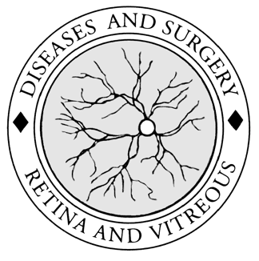
Alberta Retina Consultants
Excellence in patient care, research and teaching
Mark D. J. Greve*  MD, FRCSC  Brad J. Hinz*  BSc, MD, FRCSC, ABO  Matthew T.S Tennant*  BA, MD, FRCSC, ABO  Chad F. Baker*  BSc, MD, FRCSC  Rizwan Somani*  BSc, MSc, MD, FRCSC, ABO  David S Ehmann*  BSc, MD, FRCSC,  ABO  *professional corporation  Research  AMD  Diabetes  Vascular Occlusion  Retinal Surgery  Hereditary eye diseases  University of Alberta  Clinical & Surgical  Teaching  Tele-ophthalmology  Advanced Medical & Surgical Management of Retinal and Vitreous Disease | October 24, 2017  We are very excited to welcome Dr. David Ehmann to Alberta Retina Consultants. Dr. Ehmann was one of our past residents in ophthalmology at the University of Alberta. After residency he completed a two year fellowship at the prestigious Wills Eye Hospital in Philadelphia. He has been an excellent addition since joining our practice in July of this year.  We are thankful for all the helpful feedback we received from many of you. This, as well as our own desire to maximize quality of care and patient triage, has motivated us to improve our referral request form. We have condensed it into a single page for easier use.  We also ask that you send your regular referral letter including visual acuity, refraction, history and any other pertinent information you feel is beneficial, as this is very helpful to us.  We thank you for your continued referrals and support in allowing us to share in the care of your patients.  The physicians at Alberta Retina Consultants

